**Phase-1 First Increment**

**Project Restaurant Finder**

**Group #13**

Katta Nikitha

Dandamudi Naga Mounika

Goli Venkata Govardhan

**CONTENTS**

**I. Introduction**

**II. Project Goal and Objectives**

Overall goal

Specific objectives

Specific features

Significance

**III. Project Plan**

Issues

Burn Chart

Graphs of team member’s contribution

**IV. First Increment Report**

Detail Design of Features

Implementation

Deployment

Project Management

Bibliography

**I. Introduction:**

Restaurant Finder application is an android based application with an objective of finding restaurant based on the requirement which are location and the cuisine details entered by the user. The locations of various restaurants with their basic services available and the daily specials. By this application the user not only can locate the restaurants that are nearby and also can make choice of best restaurant based on the rating.

This application let the user view the menu in the restaurants nearby and also the nutrition value offered by the items in the menu. Health diet is important for prevent any health issues. Health Issues occur due to malnutrition which is caused due to nutrition imbalance or excessive intake of junk food. It is important for us to know the nutrition value of the food we eat, and also to what extent it is meeting the daily requirement. The main aim here in this application is to let the user find a best restaurant of his/her choice based on their location and cuisine requirements and can also know the nutrition value of the food they want to eat and can also know to how much they are meeting their daily nutritious requirement.

**II. Project Goals and Objectives:**

**Over- All Goal:**

1. The main goal of Restaurant Finder application is to find the information about the location of various restaurants near our location.
2. The route to these restaurants and their basic services available.
3. The list of items and their costs or the menu in the restaurant and also their daily specials.
4. The nutritional value and calorific value of the items in the menu.
5. Compare the nutritional value of the intake food with the available standard per day intake of different type of nutrients.

**Specific objectives:**

1. The user can locate the restaurants nearby his location and routes to these restaurants.
2. The user can also view the menu or the list of items with their cost.
3. Suggest the items with high nutritional and calorific value.
4. Analyze the nutritional value of the food we eat with the standard per day intake of nutrients.

**Specific Features:**

1. Location and directions to the restaurants depending on our requirement of type of cuisine.
2. Suggesting the food with high nutritional and calorific values best suited.

**Significance:**

1. The user can make a choice of best restaurant depending on his location and the type of food he like.
2. Can maintain healthy diet by suggest the food with high nutritional and calorific value.

**III. Project Plan:**

**Issues:**

1. Data base connection
2. Maps Activity
3. Layouts
4. Testing

**Burndown Chart**

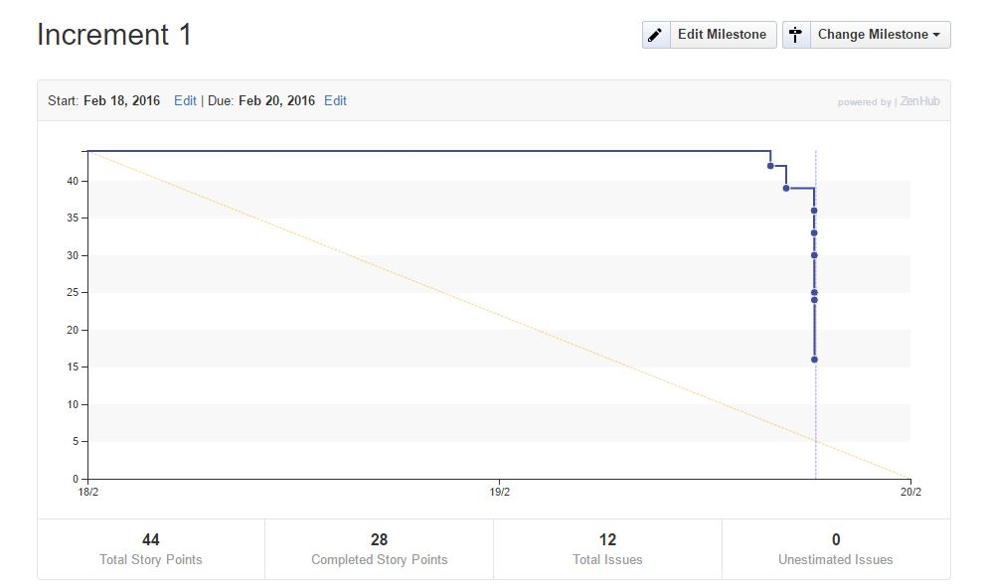

**Graphs for contribution of all the team members:**

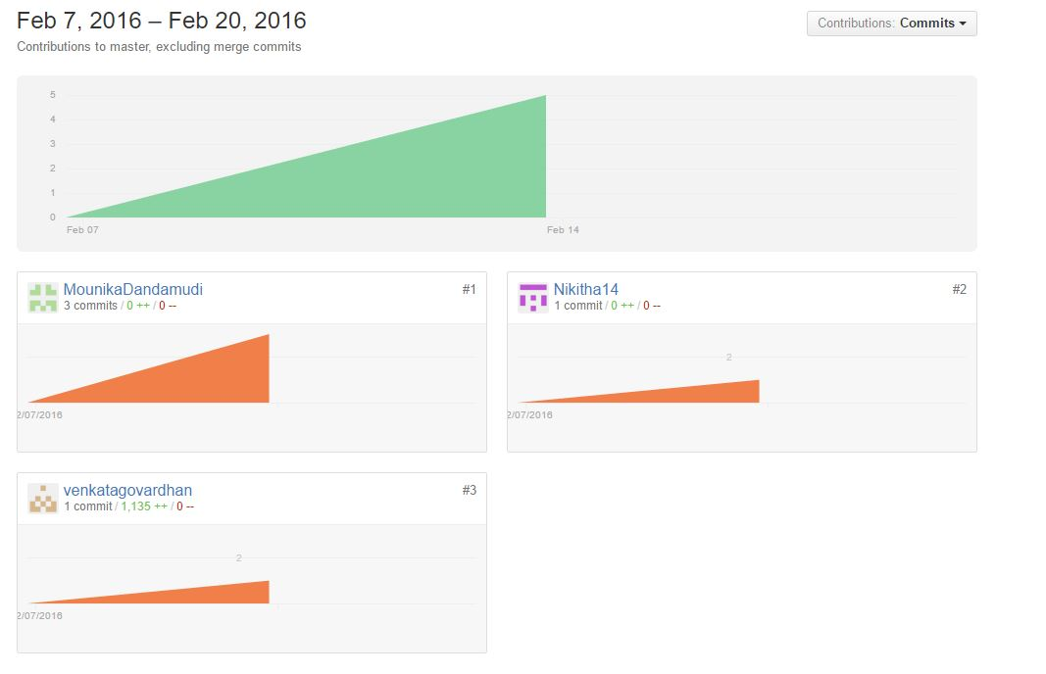

**IV. First Increment Report:**

As a part of first Increment we created Login, Register, Personal Info and Home page for the users. Any user can access Restaurant finder by login or registering in with their personal info.

A new user after registering with their personal info, can login by their entering their username and password and enter into Restaurant finder application.

After login the user's current location can be pointed out using the existing Network Provider.

**Detail Design of Features:**

**Wireframes:**

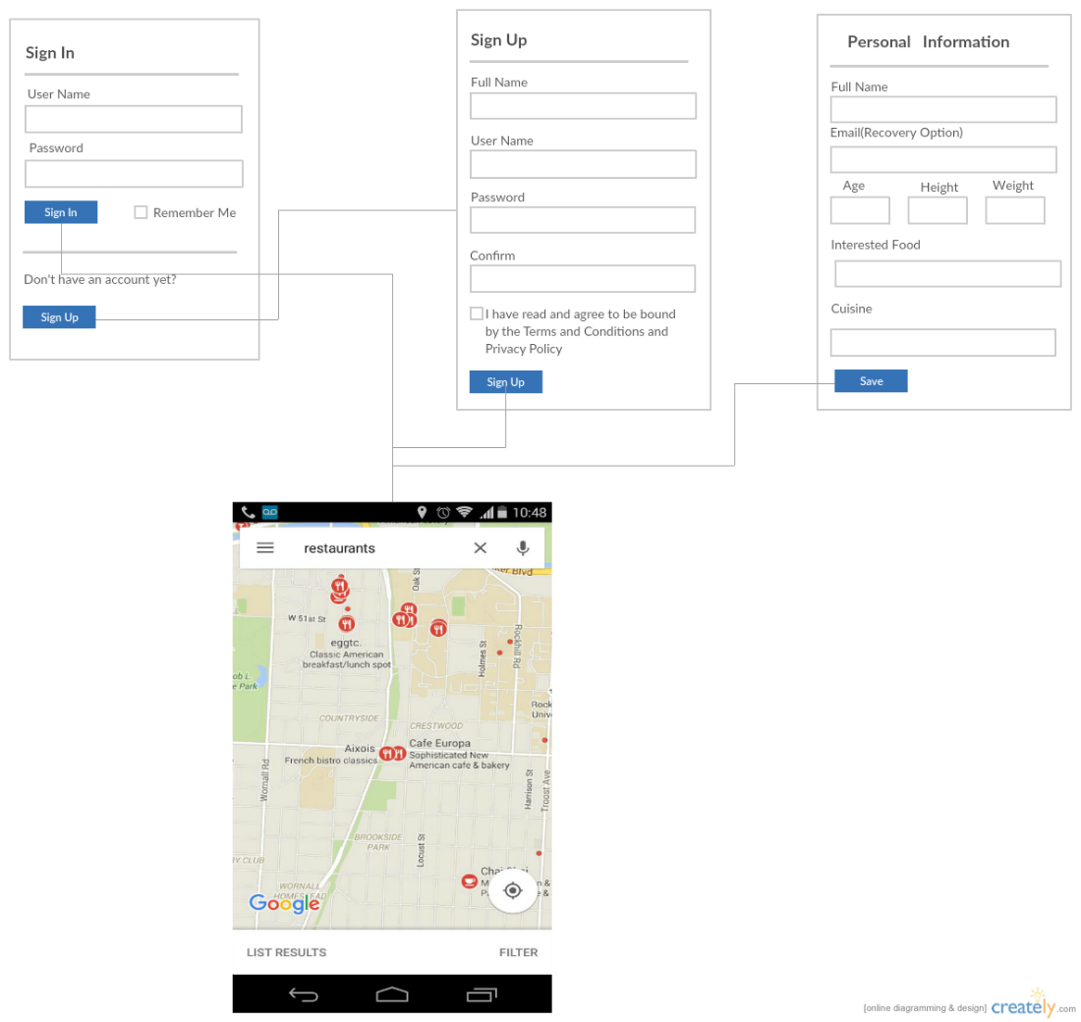

**Sequence diagram:**

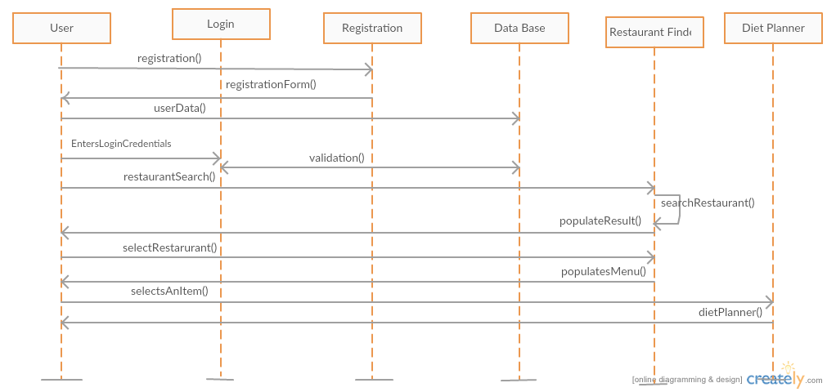

**Class diagram:**

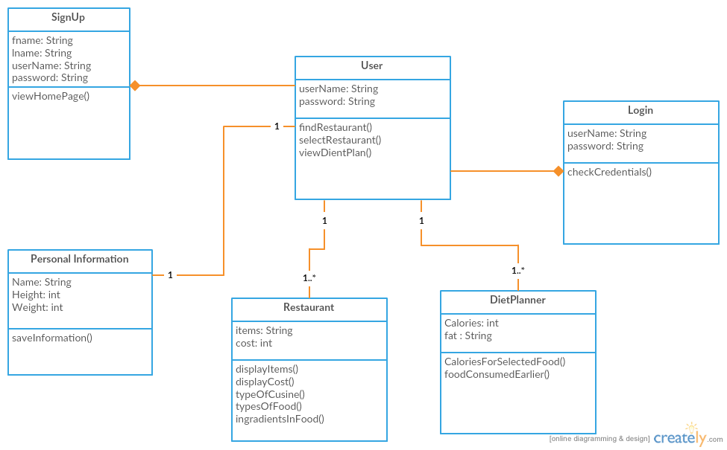

**Use Case diagram:**

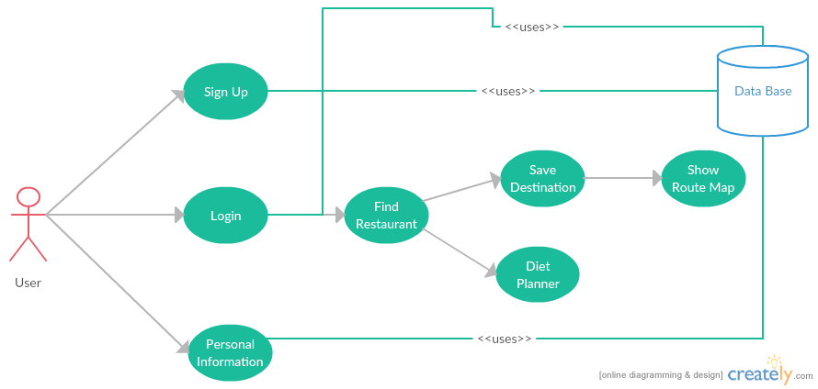

**Implementations:**

Restaurant Finder app consists of Login page, Register Page and personal info and Home page are created in android studio.

Personal info of users is stored using SQLite.

**Deployment:**

Restaurant Finder application is deployed on mobile and explained in the below screen shots.

 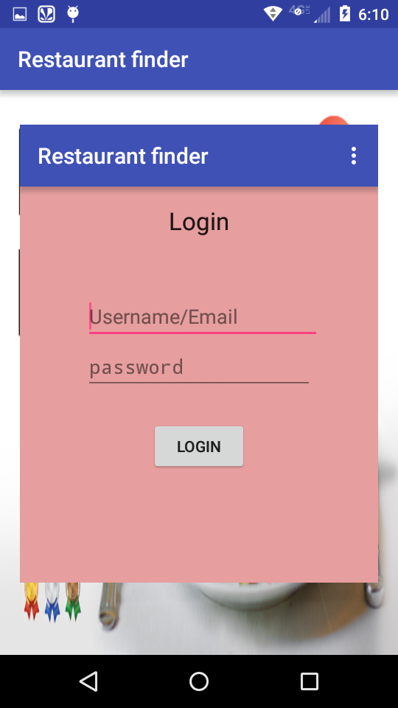

Login page of this restaurant finder app consists of Username/email and password, if the details of user are given then we can get the location of the user.

A new user has to first register to access this app, the register page or sign up consists of the personal info of the user, which on entering the info by the user we can login to the app by username/email and password.

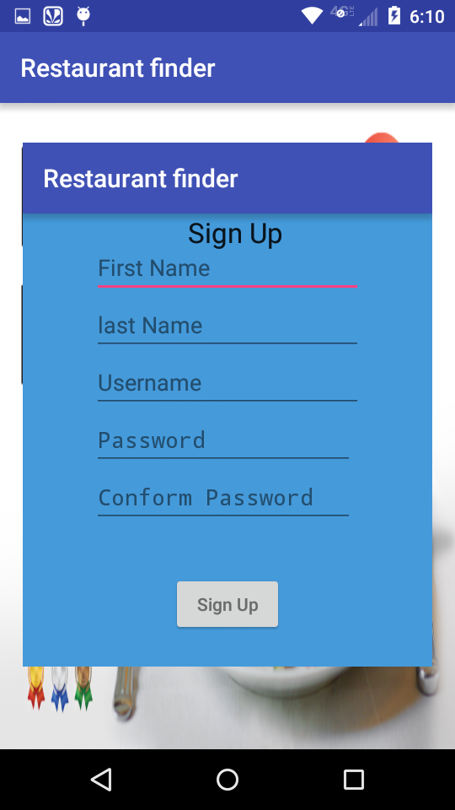 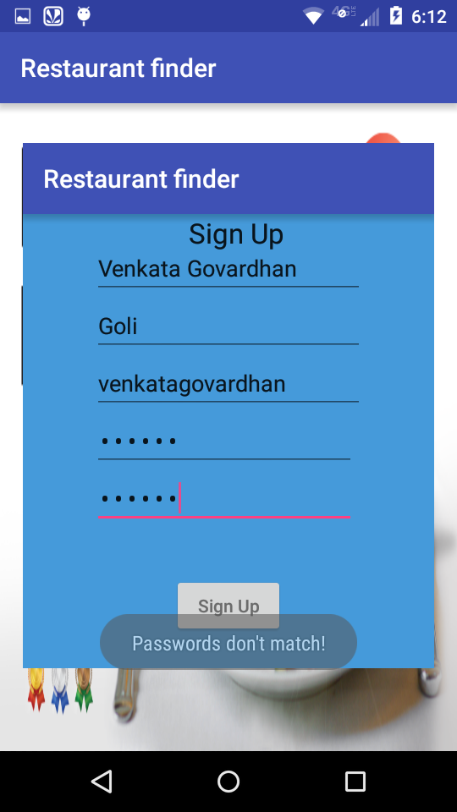

The details of the users are being stored and after signup these details can be used for login to access the restaurant finder app.

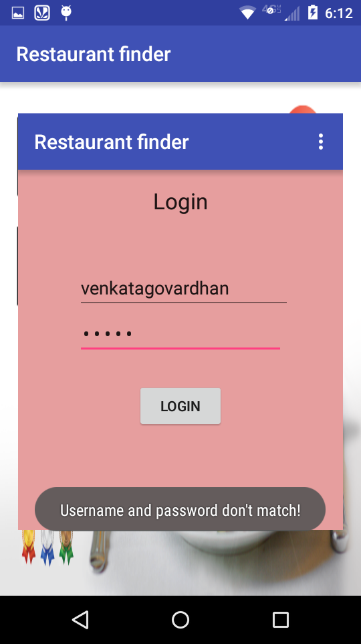 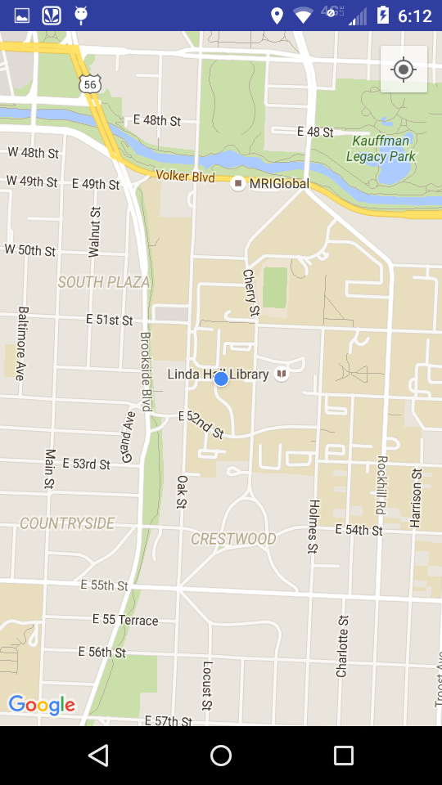

**Project Management:**

**Work completed:**

Basic design phase using class diagram, uml diagram and Use case diagram is completed.

The application basic design view phase using wireframes is completed.

The restaurant finder app's basic design-home, login, register and personal info pages are created.

The personal info of the users are stored using SQLite.

**Work to be completed:**

Call to restaurant API has to be made.

Diet planner has to be implemented further.

**Bibliography:**

<https://console.developers.google.com>

<http://developer.android.com/tools/studio/index.html>